**Interview Notes**

1. What are the different kinds of items/materials in your Library?

We have Books, Journals, Magazines, CDs and DVDs. We also have digital version of some items like eBooks, eJournals, and Digital Magazines.

1. What is the renewal policy for different items?

The renewal policy for different items is as below

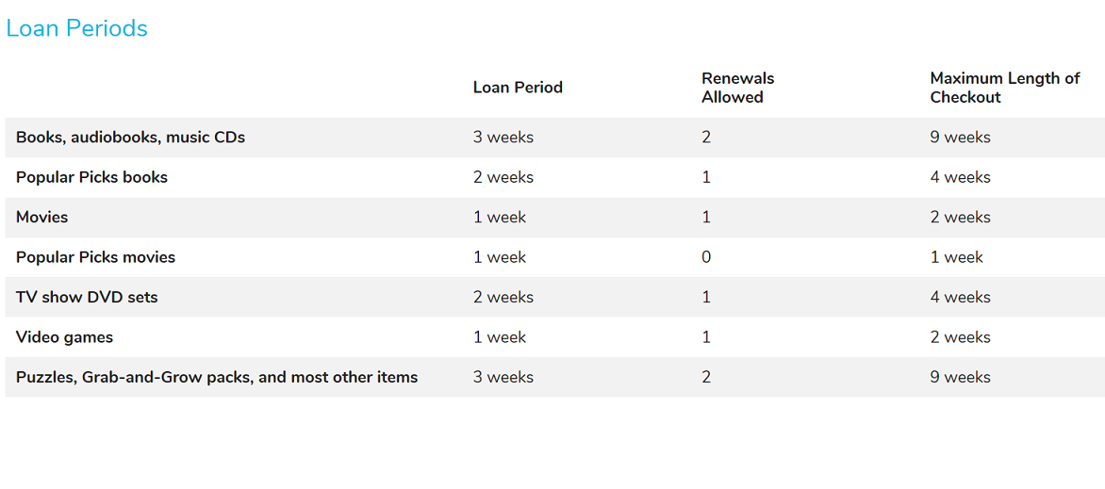

1. What is the hold policy for different items?

There is a maximum of 3 holds allowed per media. When an item is on hold by another member, it cannot be renewed and has to be returned.

1. What is the reminder/notification policy for items which are due?

**Reminders & Notices Schedule**

* 2 days before due date: email reminder
* 3 days after due date: email or paper overdue notice
* 7 days after due date: email and paper overdue notice
* 14 days after due date: library card suspended from further use; bill for item replacement

1. What are your Library hours?

We are open from

Monday-Thursday 9 am to 9 pm

Friday & Saturday 9 am to 5 pm

Sunday 12 pm to 5 pm

1. Do you borrow/loan books from neighboring libraries?

Yes, we do allow borrowing from neighboring libraries. Their items have their renewal policies and loan policies.

1. What are the different & important attributes related to the different kind of items?

Every item has a unique bar code according to which it is identified in our system. Then there are other important attributes like the kind of item itself – Book, Journal, Magazine, eJournal, Title of the item, Author/Publisher of the items, when the item was published, price of the item, language the item was published in, genre of the item, when the item was bought, Rating associated with the item, if any. Certain items like Magazines and Journals have Volumes and Issue numbers associated with them to distinguish them from previous issues. Other items like Digital Media have the URL associated with them to access them. CDs and DVDs have playback duration. Books and DVDs have ISBN numbers and Journals have ISSN numbers associated with them which allows them to be uniquely identified. So do their digital counterparts. We use internal identification numbers based on title, author, published year for items which do not have these unique identification numbers provided by the publishers.

1. Where do you store data?

Yes we store data in house. We specifically have 1 server for the system needs.

1. What do you store often?

Every piece of information we have about an item is stored in it.

1. Who are your data providers?

OCLC, it is a global library cooperative that provides shared technology services, original research and community programs for its membership and the library community at large. We are librarians, technologists, researchers, pioneers, leaders and learners. With thousands of library members in more than 100 countries, we come together as OCLC to make information more accessible and more useful.

1. What do you print often?
2. What are the different kinds of reports you need in your operations?

We do generate reports on all sorts of stuff such as circulation stats etc

1. What do you view often?

We often have to checkout and check in items on our system. While doing this we often view member id number, item bar codes, availability status, holds, if any, dates when checked out and due dates for the item. Then we also view member fines if any when the items are being checked in or reported otherwise to be lost or damaged.

1. What do you search often?

We often have to look up an item based on its title and author. There are other search options to find a media based on year published and format and availability status.

**References**

* 1. Schaumburg Central Public Library, Schaumburg, IL (Website and Staff).
  2. Vernon Area Public Library, Lincolnshire, IL (Website).